Report

|  |  |
| --- | --- |
| **Subject** | Planning Proposal to rezone part of the land at 123 Taylor Rd Chilcotts Grass |
| **TRIM Record No** | BP19/1557:EF19/495 |
| **Prepared by** | Strategic Planning Project Officer |
| **Reason** | To seek a Council resolution to support an amendment of the Lismore Local Environment Plan (LEP) to allow for the rezoning of part of land at 123 Taylor Rd, Chilcotts Grass and to seek a Gateway Determination from the Department of Planning, Industry and Environment. |
| **Strategic Theme** | Our built environment |
| **Strategy** | Our land-use planning caters for all sectors of the community. |
| **Action** | Ensure a diverse range of land use and development opportunities are available. |

|  |
| --- |
| Executive Summary On April 2, 2019, a draft Planning Proposal was received to rezone part of the land at 123 Taylor Road, Chilcotts Grass (Lot 2 DP1185561) from RU1 Primary Production to R1 General Residential. After consultation with the applicant and landowner, it was agreed that the western part of the site is more suitable to be rezoned E3 Environmental Management to protect areas of Lowland Subtropical Rainforest and the riparian area along Tucki Tucki Creek. Therefore, the proposal was amended to rezone part of the land from RU1 Primary Production to R1 General Residential and E3 Environmental Management.  The proposed rezoning will be achieved via changes to the Lismore Local Environmental Plan zoning, height of building and minimum lot size maps. No changes are required to the Lismore Local Environmental Plan 2012 written instrument. The proposal, if approved, would allow a future development application to be lodged for a new subdivision of approximately six (6) to eight (8) lots.  An assessment of environmental and physical constraints has not revealed any significant impediments that cannot be resolved or the need for further technical reporting.  It is recommended that Council support the attached Planning Proposal for the purposes of seeking a Gateway Determination from the Department of Planning, Environment and Industry. |

*Do not delete this line*

Recommendation

|  |
| --- |
| That Council:   1. support the Planning Proposal to amend the Lismore Local Environment Plan 2012 as detailed in Attachment 1 of this report to rezone part of the land at 123 Taylor Road, Chilcotts Grass (Lot 2 DP1185561) for the purpose of seeking a Gateway Determination; 2. forward the Planning Proposal to the Department of Planning, Industry and Environment with a request for a Gateway Determination; 3. agree that staff place the Planning Proposal on public exhibition and consult with government agencies in accordance with a Gateway Determination and report back to Council any issues raised by government agencies and in public submissions during public exhibition. |

*Do not delete this line*

Background

On April 2, 2019, a draft Planning Proposal was received to rezone part of the land at 123 Taylor Road, Chilcotts Grass (Lot 2 DP1185561) from RU1 Primary Production to R1 General Residential. The site is identified within Council’s Growth Management Strategy (GMS) as an ‘urban fringe investigation’ site and is included in North Coast Regional Plan 2036 Urban Growth Area map for the Lismore LGA. The proposed rezoning will assist in making new residential land available for the 3350 new dwellings that are anticipated to be needed to meet population growth by 2036.

After consultation with the applicant and landowner, it has been agreed that the western part of the site is more suitable to be rezoned E3 Environmental Management to protect areas of Lowland Subtropical Rainforest and the riparian area along Tucki Tucki Creek.

Location and Characteristics of the subject site

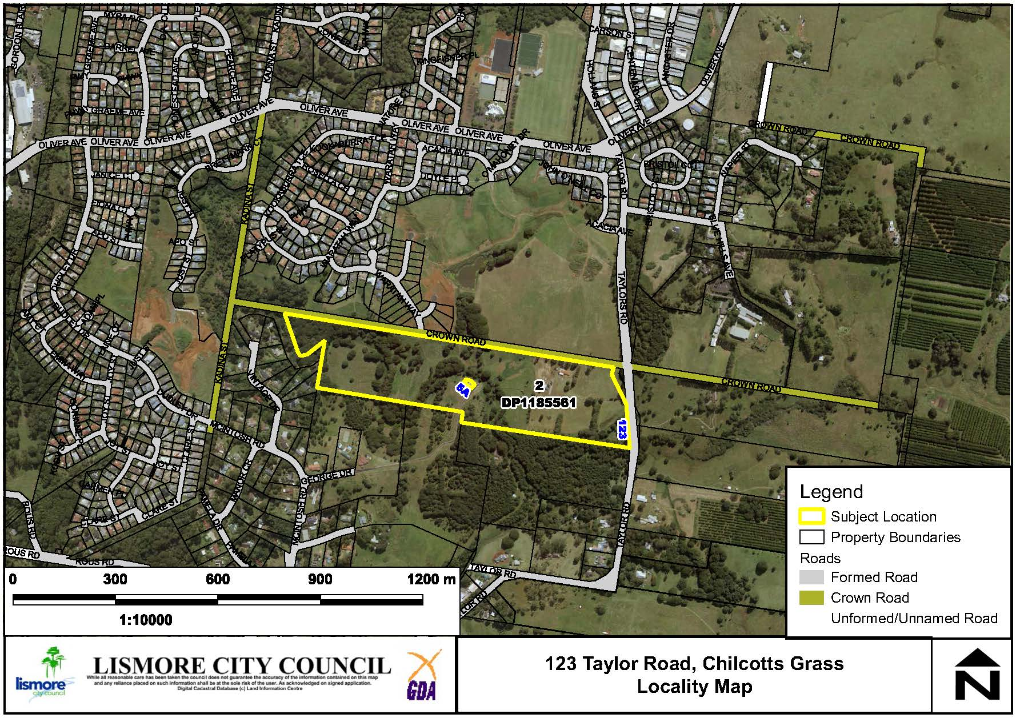

**Figure 1: Site Location**

123 Taylor Rd Chilcotts Grass (Lot 2 DP1185561) is approximately 20.09 hectares and comprises a dwelling and various farm sheds. The land is currently used for grazing horses. The western part of the site proposed for rezoning is approximately 5.3 hectares and is the area identified in the GMS as a ‘potential urban fringe’ investigation area and is located within the urban expansion limit. (See Figure 2).

The western part of the land and the riparian area along Tucki Tucki Creek are comprised of closed forest consisting primarily of Camphor Laurel with planted eucalypts. The eastern section of the subject area is predominately cleared of native vegetation. The slope varies from undulating to hilly (20-33%).

The site is located approximately 7km by road from the Lismore CBD and 2km from the Goonellabah shopping centre and is bordered by the Waterford Park residential estate to the north and a future residential estate (Hidden Valley) to the south. The area proposed for rezoning is located adjacent to an area zoned RE1 Public Recreation, part of which is currently owned by Council. The remainder is included on the Local Environment Plan (LEP) Land Reservation Acquisition map and the Tucki Tucki Creek Acquisition and Embellishment plan within LCC’s Section 7.11 Contributions Plan and will ultimately be acquired by Council.

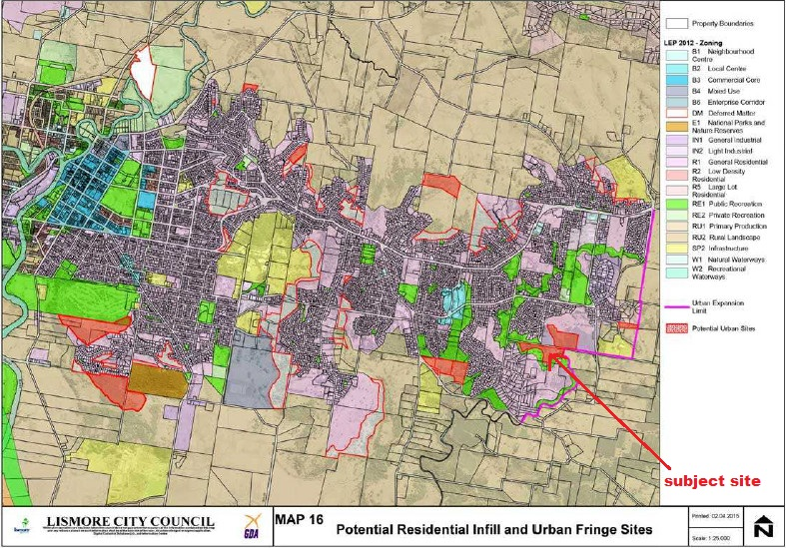

**Figure 2: Extract from the Growth Management Strategy (GMS) showing the subject site as part of the urban fringe investigation areas.**

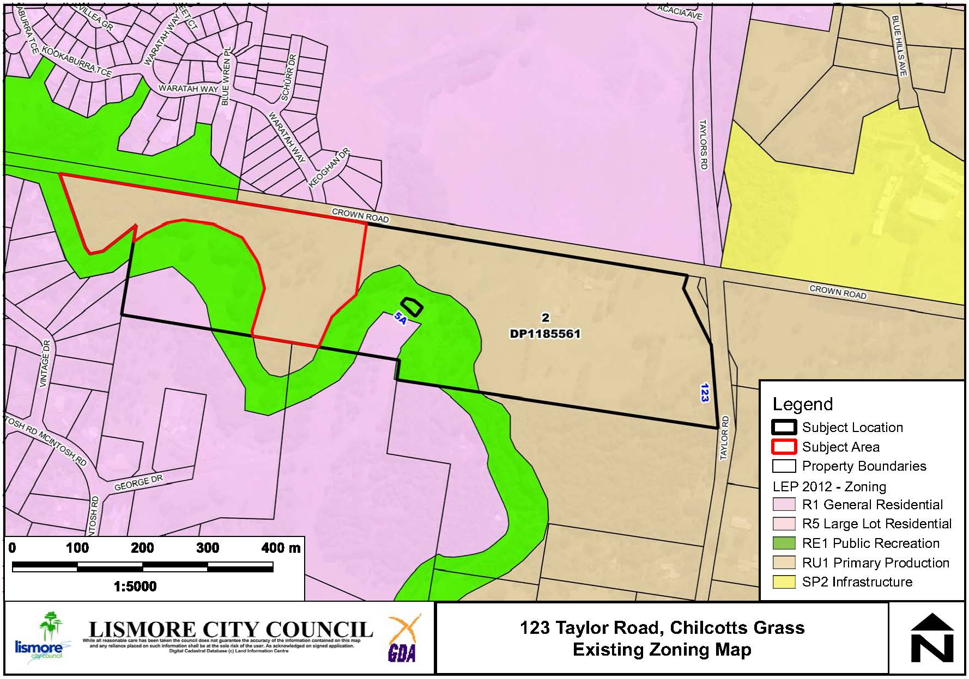

**Figure 3: Subject area and existing zoning.**

Environmental, Social and Economic Impact Assessment

Environmental and physical constraints

**Koala and other threatened fauna habitat**

The Biodiversity Assessment Report lists eight (8) candidate threatened fauna species having potential of occurring in the subject land, with only the koala known to occur.

The site is mapped as containing areas of primary koala habitat according to Lismore Council mapping as shown in Figure 4. Koalas were observed on site by the consulting ecologist from Land & Fire Assessments (L&FA) during survey work in areas not mapped as primary koala habitat. The L&FA ecologist has stated that the areas mapped by Council do not support koala food trees but has identified established eucalypts further south along Tucki Tucki Creek that should be considered as ‘preferred koala habitat’ as shown in Figure 5.

A proportion of the area mapped by Council as primary koala habitat area was cleared prior to the preliminary biodiversity assessment and is shown in the L&FA consultant’s report as “since cleared vegetation”*.* It was observed by Council staff at a site inspection that this land had been cleared and the matter was referred to the (former) Office of Environment and Heritage for further investigation. No subsequent action was taken against the landholder as the clearing was deemed to be for “sustainable grazing” which is an allowable activity under the *Local land Services Act 2013*.

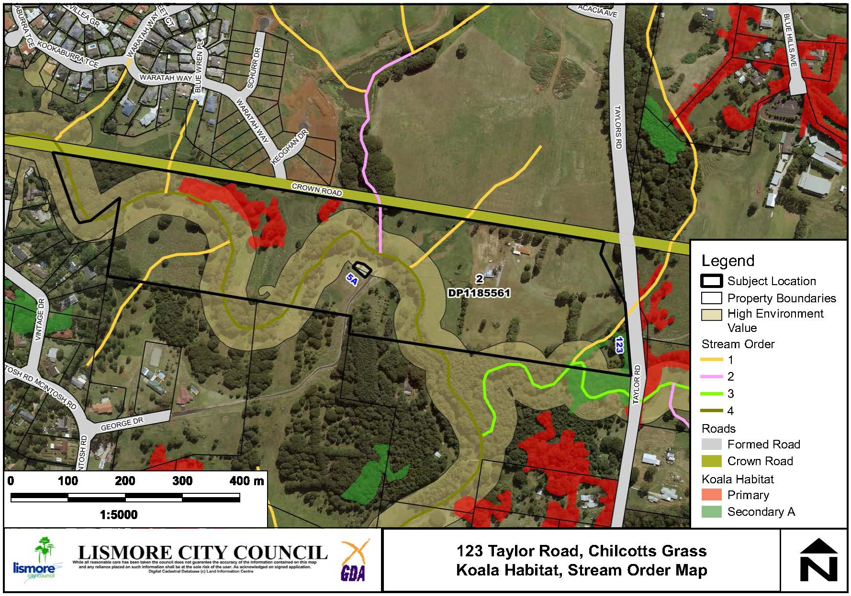

**Figure 4: Lismore Council mapping of koala habitat and high conservation value vegetation.**

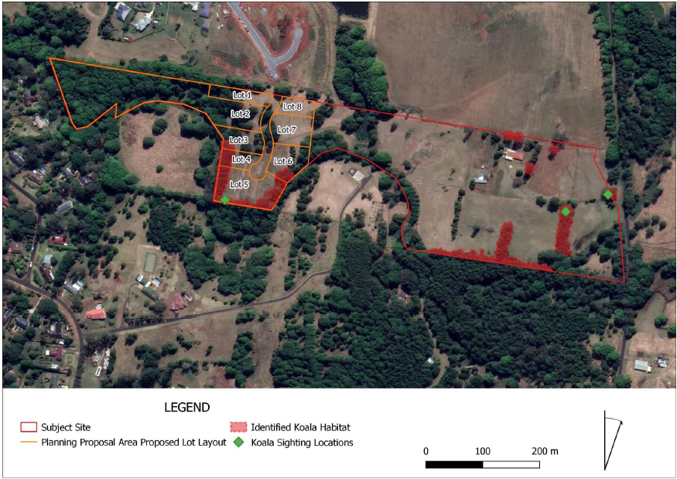

**Figure 5: Koala habitat and sightings (and possible subdivision layout).**

Koalas utilise the site for breeding and foraging and the area identified as habitat within the subject area is considered to be a stepping stone in the connectivity to the broader landscape which is required to support the safe movement and dispersal of the species. Koala habitat within the site is currently connected; however, there is significant modification of koala habitat (loss and gain) across adjacent sites due to development in the immediate and surrounding area.

The Planning Proposal will not directly impact on the existing koala habitat and a requirement for a 40m buffer from Tucki Tucki Creek will ensure that no building works can be undertaken close to the areas identified as koala habitat.

Any future DA will be considered against the criteria for a ‘small impact development’ in Lismore City Council’s Comprehensive Koala Plan of Management (CKPoM) and mitigation measures are nominated that can be included with any subsequent DA. These mitigation measures include;

* Lot layout and road design that maintains habitat linkages for the safe koala movement
* Bushfire asset protection zones that do not remove koala food trees
* The use of suitable designed boundary fences and suitable safety provisions for swimming pools

**Threatened Flora / Vegetation Communities**

The site contains areas of Lowland Subtropical Rainforest Threatened Ecological Communities (TEC), predominantly in the western part of the planning proposal area.It is affected by significant weed infestation, particularly camphor laurel and privet. The area is intended to be rezoned E3 Environmental Management to limit the development that can occur and to encourage the retention and improvement of the TEC.

**Watercourses**

Tucki Tucki Creek is a fourth order stream on this site as shown on Figure 4. A preliminary enquiry was sent to the Natural Resource Access Regulator (NRAR) regarding buffer requirements to a fourth order stream. NRAR’s guidelines for riparian corridors are that a 40m buffer should be maintained as measured from the high bank. NRAR commented that the ‘indicative’ lot layout provided shows physical works (i.e. dwellings) could be located outside of the 40m buffer. Infrastructure (sewer) was indicated on the indicative lot layout to be within the 40m buffer, but this is consistent with the NRAR’s guideline matrix that permits certain activities within the outer 50% of the buffer area.

NRAR noted that the indicative lot layout had several properties with direct access to Tucki Tucki Creek which is ‘undesirable’ as it could lead to encroachment into the core riparian zone and would create additional Basic Landholder Rights (BLR) to extract water from the creek. In consultation with the landowner, the Planning Proposal was amended to include part of the site in the E3 zone to provide for a 40m riparian buffer all the way along the western part of the subject area. The proposed R1 land will not have direct access to Tucki Tucki Creek as the creek line is within an area already zoned RE1 Public Recreation to be purchased by Lismore City Council. The outcome is that no additional waterfront lots will be able to be created as a result of the Planning Proposal.

**State Significant Farmland**

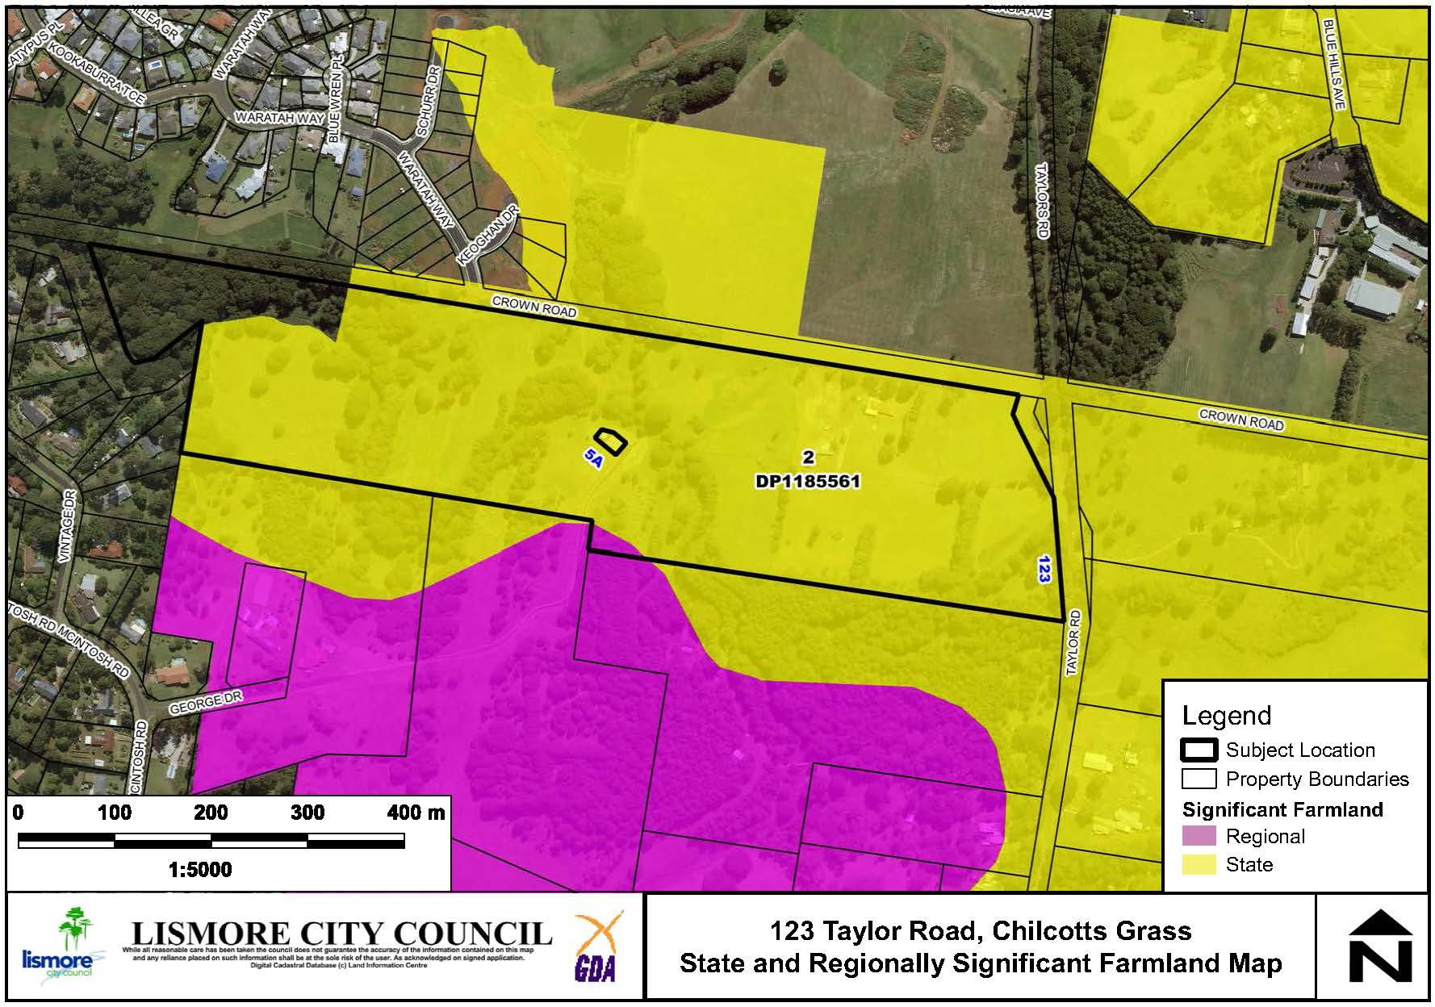

**Figure 6: State and Regionally Significant Farmland.**

The site is mapped as State Significant farmland. A small area of macadamias was cleared (prior to 2015) and the land is currently used for the grazing of horses. As the land to both the north and south has been zoned for residential use and given the small amount of land available for agriculture across the whole site, it is considered extremely unlikely that any intensive agriculture will be undertaken in the future.

The Northern Rivers Farmland Protection Project (NRFPP) outlines principles whereby state and regionally significant farmland may be included in an urban settlement strategy. These principles were applied when the subject site was included within Lismore’s GMS for *‘potential residential infill and urban fringe sites’*, which was endorsed by the (then) Department of Planning and Environment on the basis that:

* the land is fragmented from contiguous agricultural use by Tucki Tucki Creek and land already developed for urban residential use to the north and south;
* the site is not suitable for commercial cultivation or horticulture due to the slope and proximity to a watercourse;
* the proposal is minor in nature and there are no likely impacts on existing agricultural uses (which are limited to the eastern boundary).

**Contaminated Land**

A preliminary contaminated land assessment was presented as supporting information to the planning proposal. Soil sampling was carried out in the development site and the results indicate that contaminants were below the Health Investigation levels (HIL) and the site is suitable or can be made suitable for the proposed residential use. At the sub-division DA stage, the matter of contamination will need to be revisited and additional technical reporting will be required to meet EPA Sampling Guidelines.

**Bushfire**

The site is mapped as containing bushfire prone vegetation. A preliminary assessment of bushfire hazard indicates that future development will be able to meet the requirements of *Planning for Bushfire Protection 2006*. As the site is mapped as bushfire prone land, the Planning Proposal will require referral to the NSW Rural Fire Service.

**Stormwater Management**

Due to the scale of the rezoning, geographic location and scale of future road and drainage works, technical reporting in relation to the matter of stormwater quality can be reasonably considered at future subdivision stage. Given the proximity to Tucki Tucki Creek, any stormwater works within 40m of the creek will require referral to NRAR at the sub-division stage.

Social, economic and cultural heritage impacts

**Aboriginal and European Cultural Heritage**

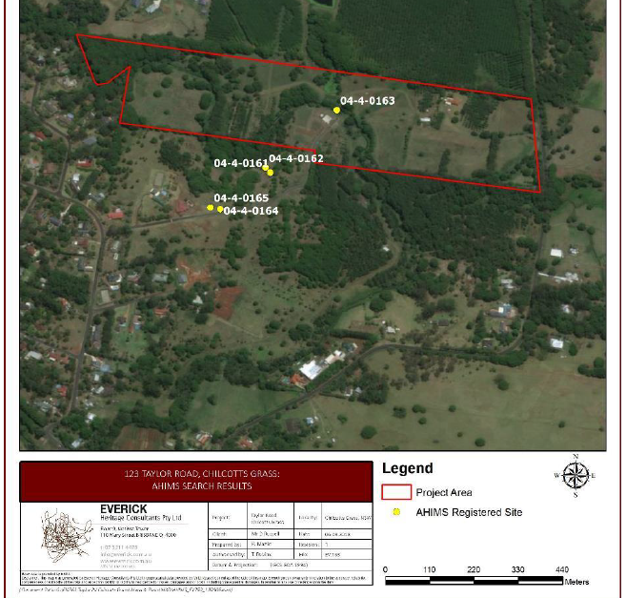

**Figure 7: AHIMS sites within 100m of the project area.**

A report by Everick Heritage Consultants assessing the cultural heritage significance of the site was provided by the applicant. The assessment includes consultation with representative Aboriginal parties.

AHIMS record 04-4-0163 is in the centre of the property, being a grinding groove in the flow zone of Tucki Tucki Creek at its confluence with a tributary from the north. This registered site is NOT located within the Planning Proposal area – it is located further to the east - and the report concludes the following regarding this record:

* no evidence that a grinding groove of Aboriginal origin was present at this registered site;
* suggests record 04-4-0163 is located within allotments proposed for public reserves (RE1 zone);
* suggests record 04-4-0163 is not within the urban investigation area and unlikely to be subject to impacts from development.

**Economic Impacts**

The planning proposal will facilitate the development of up to eight (8) additional lots which is unlikely to create any adverse economic effects. There is likely to be some additional economic activity generated by development of the land and construction of future dwellings.

**Social Impacts**

Due to the nature and scale of the proposal there are not expected to be any adverse social impacts. A social impact assessment is not triggered by LCC’s policy as the proposed rezoning will result in less than 20 dwellings. The provision of additional land for residential development will increase housing choice.

Servicing and infrastructure

**Road Network**

The site has a road access via an extension of Waratah Way. This proposal would formalise the completion of Waratah way and no further linkages are required for future public road access.

The Crown Road reserve to the north of the subject site will become superfluous to road network needs and it is recommended that it be amalgamated into the proposed rezoning area. The use of this Crown Road for public linkages and management of the Tucki Tucki Creek (RE1 Public Recreation areas) should be considered and a referral will be sent to the Crown Lands section of Department of Planning Industry and Environment following Gateway determination.

**Water supply**

The existing water main that terminates at Waratah Way can be extended to service the new development that would result from this rezoning.

**Sewerage services**

The proponent’s preliminary assessment suggests that a gravity sewerage system can service the development and if required, a low-pressure sewerage system can be incorporated into the development. This has been confirmed by Council’s development engineer.

Overview of the Planning Proposal

It is proposed to rezone part of the site from RU1 Primary Production to R1 General Residential zone and part of the land to E3 Environmental Management.

The change to the zoning map will require corresponding changes to the minimum lot size and height of building maps as shown in Figures 6 - 11.

This will be achieved by amending map sheets: LZN_006AB, LSZ_006AB and HOB_006AB.

No changes are required to the Lismore LEP 2012 written instrument.



**Figure 8: Existing zone map.**

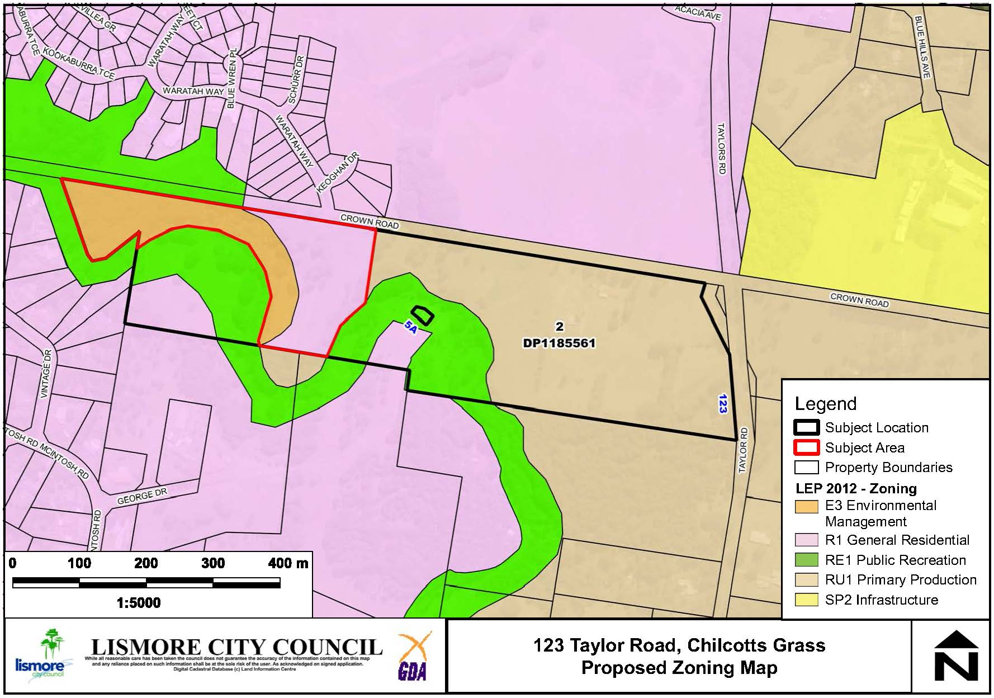

**Figure 9: Proposed zone map.**

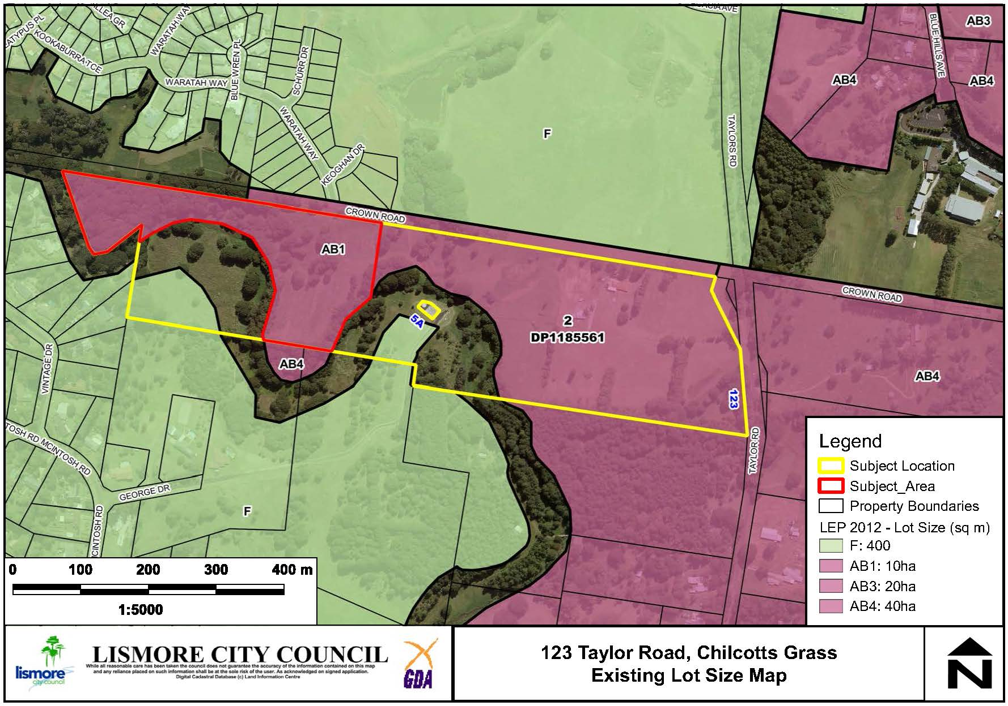

**Figure 10: Existing minimum lot size map.**

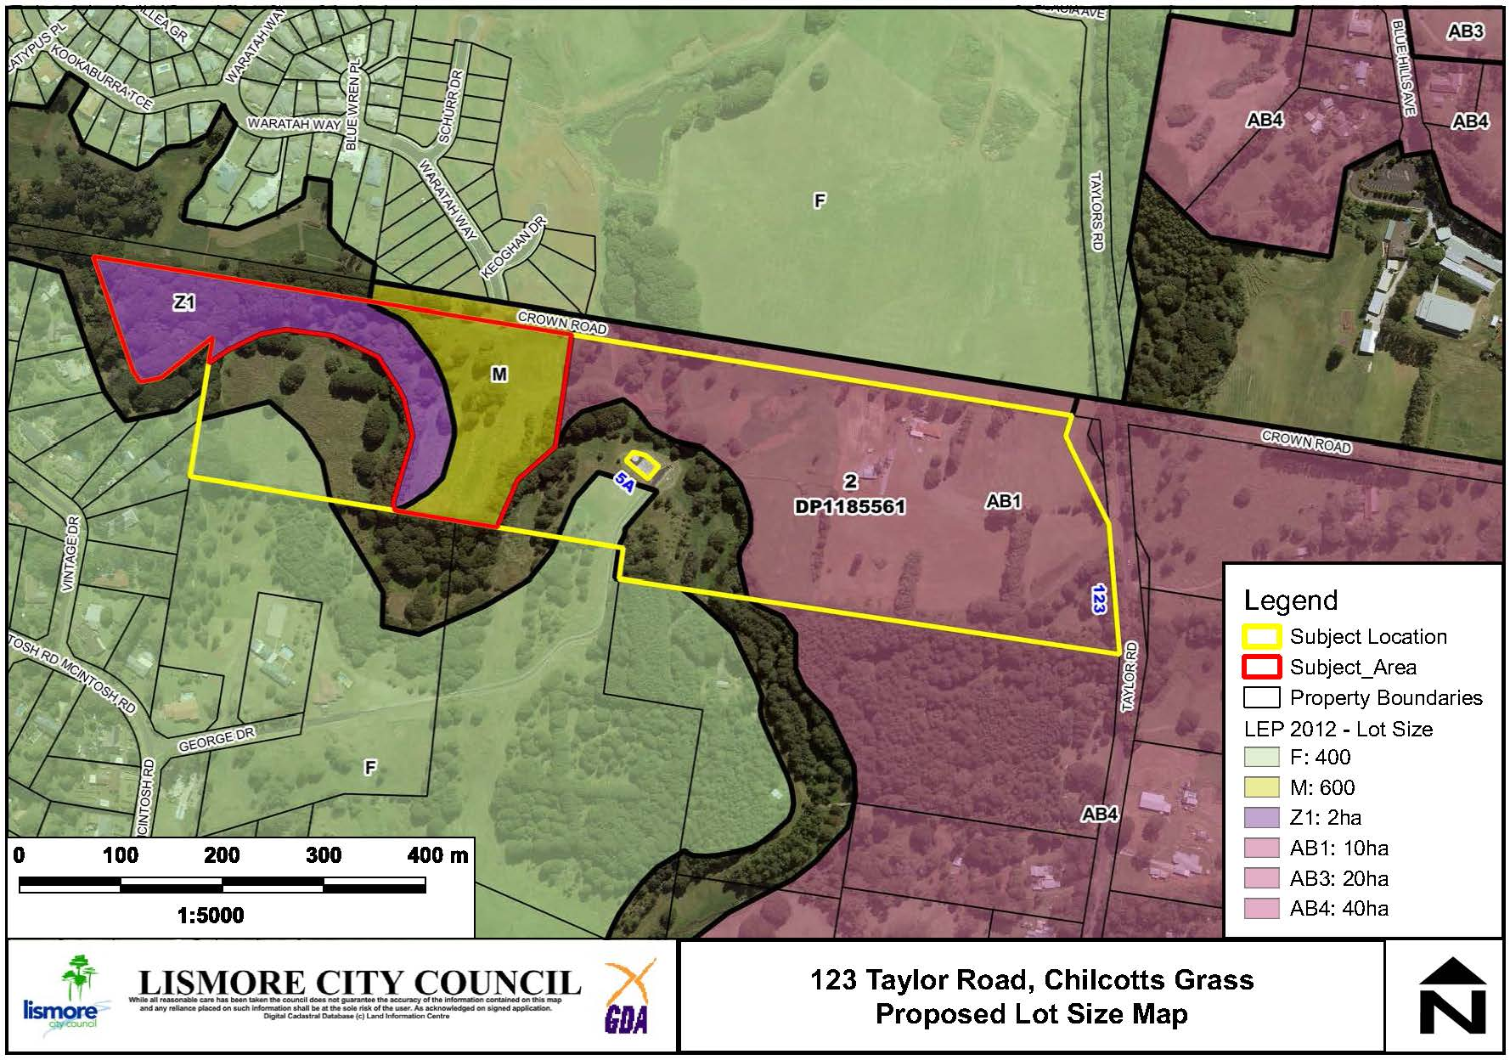

**Figure 11: Proposed minimum lot size map.**

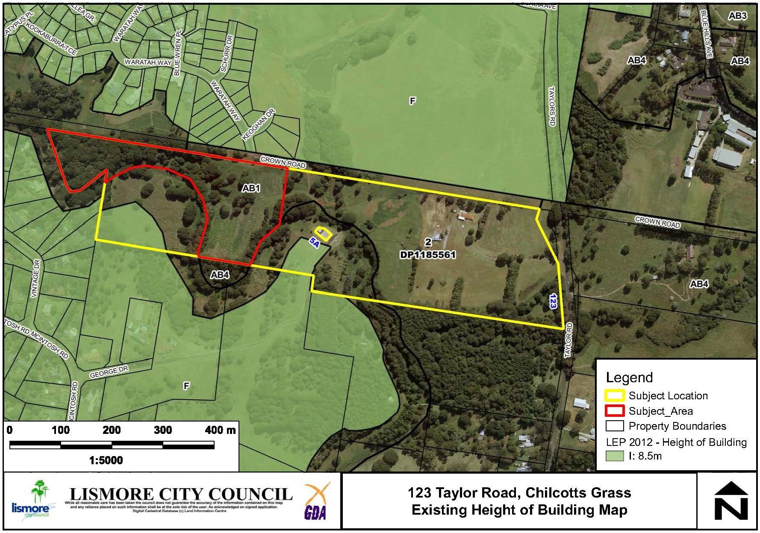

**Figure 12: Existing height of building map.**

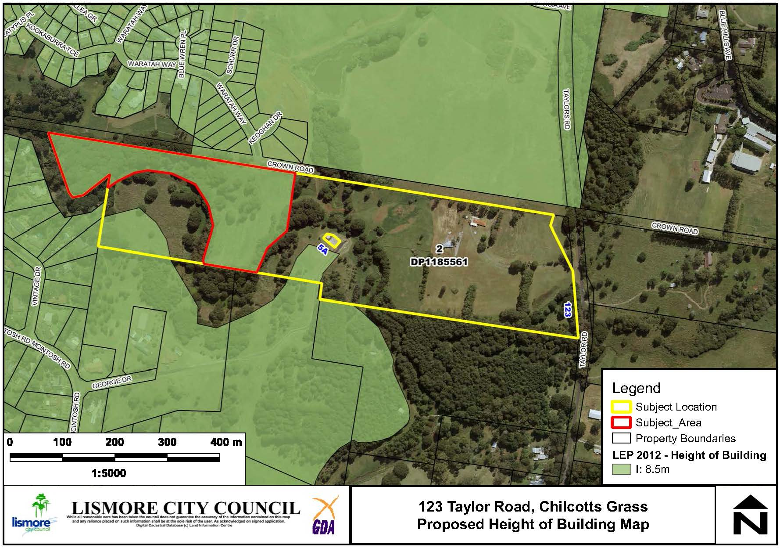

**Figure 13: Proposed height of building map.**

Table 1 provides a summary of the planning proposal.

**Table 1: Summary of Planning Proposal**

| **PART** | **REQUIREMENTS** | **DESCRIPTION OF PLANNING PROPOSAL** |
| --- | --- | --- |
| 1 | **OBJECTIVES OR INTENDED OUTCOMES** | The objective of this planning proposal is to rezone the western section of 123 Taylor Road, Chilcotts Grass (Lot 2 DP1185561), from Zone RU1 Primary Production to part Zone R1 General Residential and part Zone E3 Environmental Management. The proposal is aimed at facilitating the future subdivision of the land for residential development and to protect the biodiversity values of the riparian environment. |
| 2 | **EXPLANATION OF PROVISIONS** | The planning proposal seeks to amend the following parts of the Lismore LEP 2012:  Map sheets: LZN_006AB, LSZ_006AB and HOB_006AB.  No changes are required to the Lismore LEP 2012 written instrument. |
| 3 | **JUSTIFICATION**  **Section A- Need for the Planning Proposal**  ***Is the planning proposal a result of any strategic study or report?***  ***Is the planning proposal the best means of achieving the objectives or intended outcomes, or is there a better way?*** | The subject site is identified within Lismore’s Growth Management Strategy (GMS) as an ‘urban fringe investigation site’ and in the urban growth map for the Lismore LGA in the North Coast Regional Plan (NCRP) 2036.  A planning proposal to rezone the land is considered the most appropriate means of enabling the development of the land. |
| 4 | **JUSTIFICATION**  **Section B- Relationship to Strategic Planning Framework**  ***Is the Planning Proposal consistent with the objectives and actions contained within the applicable regional or sub-regional strategy?***  ***Is the Planning Proposal consistent with the Council’s local strategy or other local strategic plan?***  ***Is the Planning Proposal consistent with applicable State Environmental Planning Policies (SEPP)?***  ***Is the Planning Proposal consistent with applicable s9.1 Ministerial Directions?*** | The NCRP is the overarching State Government framework to sustainably manage growth for the Far North Coast. The site is identified within the NCRP as an urban investigation area.  The Planning Proposal is consistent with the following strategic planning documents:   * Imagine Lismore (Community Strategic Plan 2017-2027) * Lismore Growth Management Strategy 2015-2035 (GMS)   The Planning Proposal is consistent with applicable SEPPs as outlined in Appendix 1.  The Planning Proposal is consistent with applicable Section 9.1 Directions or any inconsistency can be justified, as outlined in Appendix 2. |
| 5 | **JUSTIFICATION**  **Section C- Environment, Social and Economic Impact**  ***Is there any likelihood that critical habitat of threatened species, populations or ecological communities or their habitats, will be adversely affected as a result of the proposal?***  ***Are there any likely environmental effects as a result of the Planning Proposal and how are they proposed to be managed?***  ***Has the Planning Proposal adequately addressed any social and economic effects?*** | The Biodiversity Assessment Report lists eight (8) candidate threatened fauna species having potential of occurring in the subject land, with only the koala known to occur. The koala habitat on the subject site is important as it provides a stepping stone in the connectivity of habitat within the broader landscape. Any future DA would be considered against the criteria for a ‘small impact development’ in Lismore City Council’s Comprehensive Koala Plan of Management (CKPoM) and mitigation measures have been proposed that could be included with any subsequent DA. It is considered that the Planning Proposal can occur without adverse impacts on the koala population at the site.  The site also contains areas of Lowland Subtropical Rainforest Threatened Ecological Communities (TEC), which are proposed to be included within an E3 Environmental Management zone.  The site adjoins Tucki Tucki creek. The proposed rezoning will allow for a 40 metre riparian buffer to be created along the western part of the proposed rezoning area, and that no new lots are created with direct creek frontage and no new Basic Landholder Rights (BLR) created allowing water to be extracted from the creek.  Bushfire, contaminated land and stormwater management issues are considered to be acceptable and able to meet legislative requirements.  Social and economic impacts have been adequately addressed with no negative impacts identified. |
| 6 | **JUSTIFICATION**  **Section D - State and Commonwealth Interests**  ***Is there adequate public infrastructure for the Planning Proposal?***  ***What are the views of State and Commonwealth public authorities consulted in accordance with the Gateway Determination?*** | Council staff have carried out a preliminary assessment of public infrastructure and determined that Waratah Way can adequately cater for the expected increase in vehicle movements, and that suitable water and sewage services are available.  It is recommended that the following authorities are consulted following the Gateway determination:   * Rural Fire Service * Biodiversity and Conservation Division (DoPIE) * Natural Resource Access Regulator (Land and Water Division) * Crown Lands   It is also proposed that the Planning Proposal be circulated to the Friends of Koala (FOK) for comment on any impacts this rezoning may have on koala movements and corridor locations and key habitat in the surrounding area. |
| 7 | **MAPPING** | It is proposed to amend the LEP maps as shown in Figures 6-11 above in this report. |
| 8 | **COMMUNITY CONSULTATION** | A 28-day community consultation period is recommended but this will be confirmed in the Gateway determination. |
| 9 | **PROJECT TIMELINE** | Recommendation of approximately 8 months to complete.  Refer to Attachment 1 for detail. |
| 10 | **DELEGATIONS** | Council does not have delegation for the plan making stage of the planning proposal as the rezoning includes the use of Zone E3 Environmental Management. |

Comments

Finance

Not required.

Other staff comments

Council’s specialist staff have assessed the Planning Proposal as required and their comments are incorporated into the relevant sections of this report.

Public consultation

Council will carry out consultation with the community following Gateway Determination. For the purposes of public notification, Council considers that a twenty-eight (28) day public exhibition period is appropriate.

Notification of the exhibited Planning Proposal will include:

* A newspaper advertisement (Local Matters) that circulates in the area affected by the Planning Proposal.
* The website of Lismore City Council and the Department of Planning, Industry and Environment.
* Letter to adjoining landholders.

The written notice will:

* Provide a brief description of the objectives or intended outcomes of the Planning Proposal.
* Indicate the land that is the subject of the Planning Proposal.
* State where and when the Planning Proposal can be inspected.
* Provide detail that will enable members of the community to make a submission.

Exhibition Material:

* The Planning Proposal, in the form approved for community consultation by the Director General of the Department of Planning, Industry and Environment.
* The Gateway Determination.
* Any studies required as part of the Planning Proposal.

The Gateway Determination will confirm the public consultation requirements.

LEP delegations

Council does not have delegation for the plan making stage of the planning proposal as the rezoning includes the use of Zone E3 Environmental Management.

Conclusion

A preliminary assessment of the Planning Proposal and a constraints analysis of the subject site has not revealed any significant impediments to proceeding to the Gateway stage. The Planning Proposal is generally consistent with relevant State Environmental Planning Policies and s9.1 Ministerial Directions and any inconsistencies can be justified. There is enough information to enable Council to support the Planning Proposal and forward it to the Department of Planning and Environment for a Gateway Determination.

*Do not delete this line*

## Attachment/s

|  |  |  |
| --- | --- | --- |
| 1. | Taylor Road Planning Proposal | (Over 7 pages) |